**Self-Care Skills from 18 months to 4 years**

How independent is your child in completing the skills listed? Work on one or two skills this week. Building independence in self-care bolsters confidence in your child.

**Self-Care Skills from 18 months- 2 year old Child**

1. Undress pants/shorts
2. Explore how to dress self (shirts tend to get stuck!)
3. Put own pajamas into drawer
4. 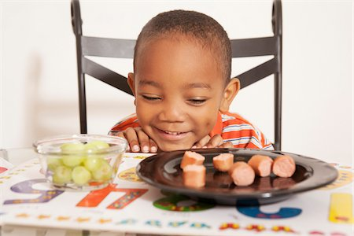Take off and stow away shoes
5. Wash face and hands (may need help)
6. Comb or brush own hair (finish up with help)
7. Hang up coat (provide hook that is accessible)
8. Serve self a snack from a shared plate onto own bowl or plate
9. Explore using a napkin
10. Explore pouring water from pitcher into own glass
11. Explore how to wipe up spills
12. Put trash into waste bin
13. Play alone for 15-40 minutes*

**Self-Care Skills for 3 year old Child**

1. Dress self (may need some help, esp. with buttons & zippers)
2. Practice using Snaps, zippers and buttons
3. Explore what weather appropriate clothing means
4. Put on shoes (it’s helpful to avoid laces)
5. Explore taking shower alone (Supervised)
6. Hang up own towel (make sure hook is height accessible)
7. Put away a few items of clothes from a laundry basket
8. Explore how to make own bed
9. Explore basic cooking (measuring, pouring, mixing)
10. Pour glass of water/milk/juice from a pitcher (see next!)
11. Wipe up own spills (helps to keep towels stored where child can reach)
12. Get a snack from the pantry (Try to keep healthy choices in reach)
13. Use a napkin at the table
14. Learn part of own address (Town and own last name)
15. Help set table (give choice of one responsibility such as napkin buddy or place mat setter)
16. Remove own plate from table
17. Explore using the kitchen sink to rinse fruits/veggies/cups
18. Play alone for up to one hour*

**Self-Care Skills for 4 year old child**

1. Continue practicing skills from the 2 and 3 year list above
2. Explore washing hair alone in shower (may need help to complete)
3. Explore more cooking skills (cracking eggs alone, making simple sandwich, cutting banana slices)
4. Learn house phone number
5. Learn own address
6. Set / remove own place setting at table
7. Learn a bit about how to work the washing machine